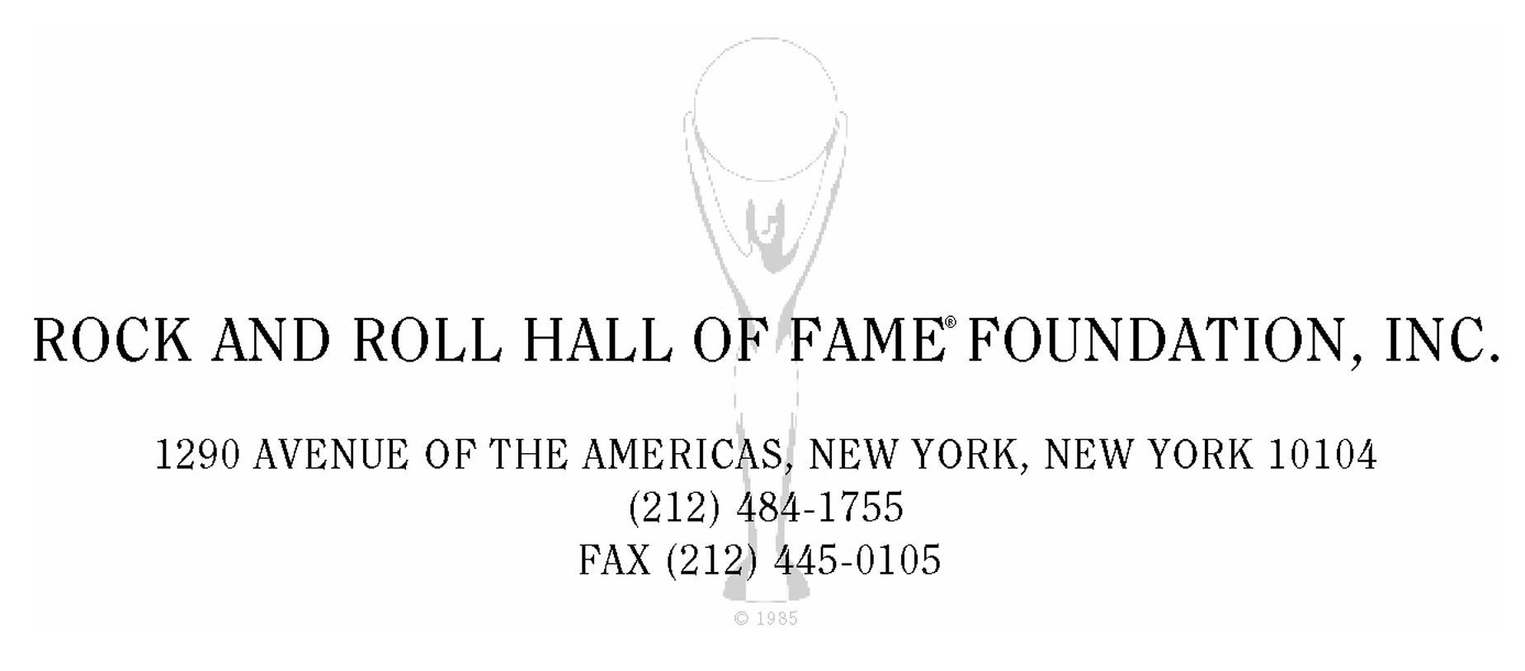

February 13, 2007

Mickey Bentson
c/o Payup Management
263 Churchill Road
Teaneck, NJ 07666

Dear Mickey,

On behalf of the Rock and Roll Hall of Fame Foundation, we are honored to inform you that your clients Melle Mel, Kidd Creole and Rahiem are being inducted into the Rock and Roll Hall of Fame as members of Grandmaster Flash and the Furious Five. The Twenty Second Annual Induction Ceremony will take place on Monday, March 12, 2007 at the Waldorf Astoria Hotel in New York City.

Please accept the Board of Directors heartfelt congratulations.

Sincerely,

Joel Peresman

